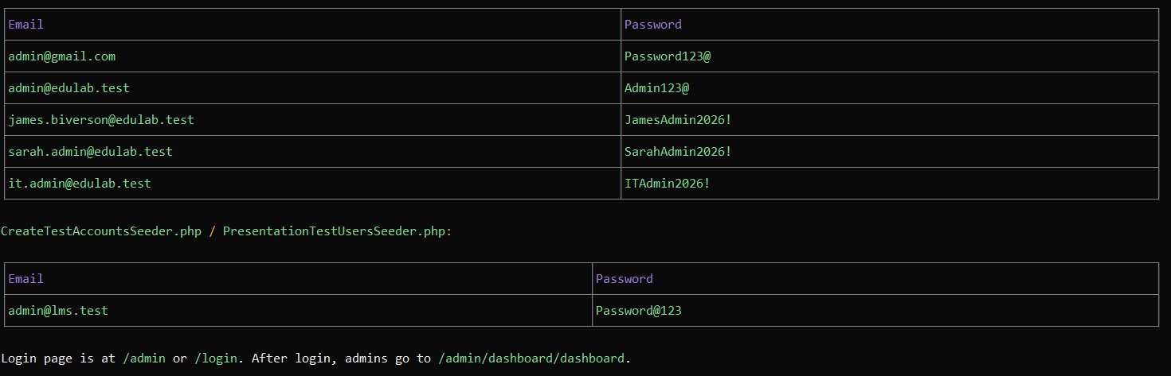
LEARNING MANAGEMENT SYSTEM DOCUMENTATION

